1. From the given emergency calls data set import the excel file and answer the following questions:

emergency calls.csv

1. Which five zip codes receive the most emergency calls?

Expected result:

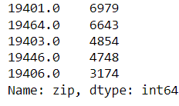

Solution:

df = pd.read_csv(r"##path of the file (emergency calls )”)

df['zip'].value_counts().head()

1. Which five towns receive the most emergency calls?

Expected result:

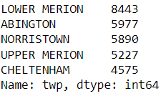

Solution:

df['twp'].value_counts().head()

1. Display the number of unique title.

Expected result:



Solution:

df["title"].nunique()

d. "Reasons/Departments" are included in the titles column before the title code. These are traffic, fire, and EMS. The reason given in titles should be added to a new column named "Reason."

For example title given as {'EMS: BACK PAINS/INJURY'} in this ems is the reason and it should be added in the reason column.

Expected value:

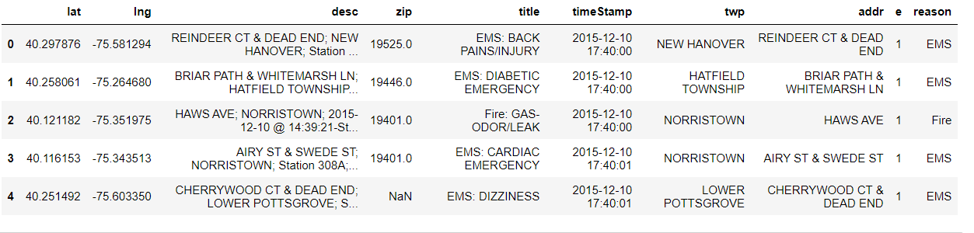

Solution:

df['reason'] = df['title'].apply(lambda title : title.split(":")[0])

df.head()

1. Display the count of each reason.

Expected result:

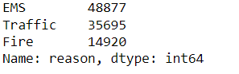

Solution:

df['reason'].value_counts()

1. Make a simple plot showing the number of calls made each month based on the dataframe.

Expected result:

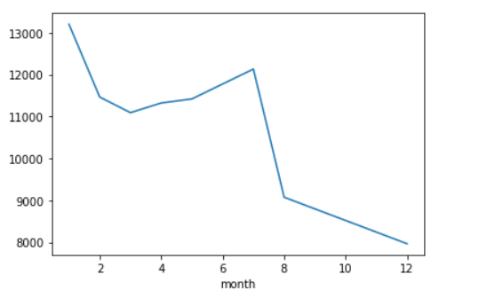

Solution:

df['timeStamp'] = pd.to_datetime(df['timeStamp'])

df['month'] = df['timeStamp'].apply(lambda time : time.month)

bymonth = df.groupby('month').count()

bymonth['twp'].plot()

1. For which reason and department it have received frequent calls.

Expected result:

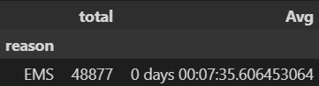



Solution:

pd.DataFrame(df.groupby('reason')['timeStamp'].agg(total='count',Avg=lambda group: group.sort_values().diff().mean())).head(1)

pd.DataFrame(df.groupby('departments')['timeStamp'].agg(total='count',Avg=lambda group: group.sort_values().diff().mean())).head(1)

1. From the given suicide report data set analyse and answer the following questions

suicide report.csv

1. Which gender reports more suicides over years and display a line plot to justify your answer?

Expected result:

Higher suicides rate – male

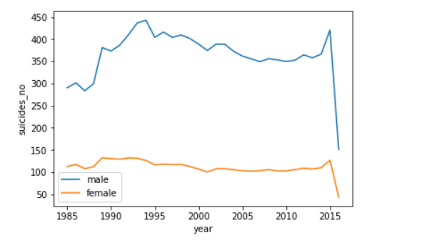

Solution:

import seaborn as sns

import matplotlib.pyplot as plt

import numpy as np

import pandas as pd

# creating dataframe

df = pd.read_csv('#file location')

df_men = df[df.sex == "male"]

df_women = df[df.sex == "female"]

sns.lineplot(df_men.year, df.suicides_no, ci = None)

sns.lineplot(df_women.year, df.suicides_no, ci = None)

plt.legend(["male", 'female'])

plt.show()

1. Which age group reports more suicides over years and display a line plot to justify your answer?

Expected result:

Suicide rate is proportional to age.

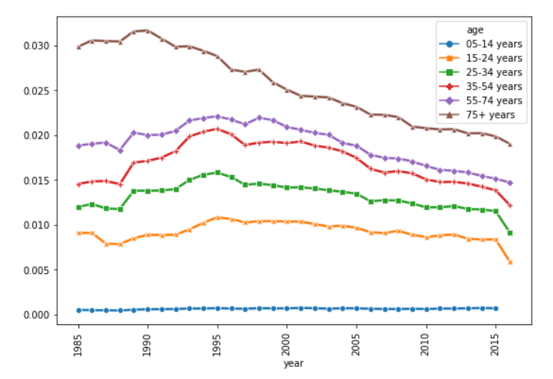

Solution:

df_age = df.groupby(["year","age"])["suicides_no", "population"].sum()

df_reset = df_age.copy().reset_index()

plt.figure(figsize=(9,6))

sns.lineplot("year", df_reset.suicides_no*100/df_reset.population, hue = "age",

data = df_reset, linewidth = 2.5, style = "age", markers=True

, dashes=False)

plt.xticks(rotation = 90)

plt.show()